
April 2025
Frank Russo, Editor

Here Comes the Sun – Our Day Begins

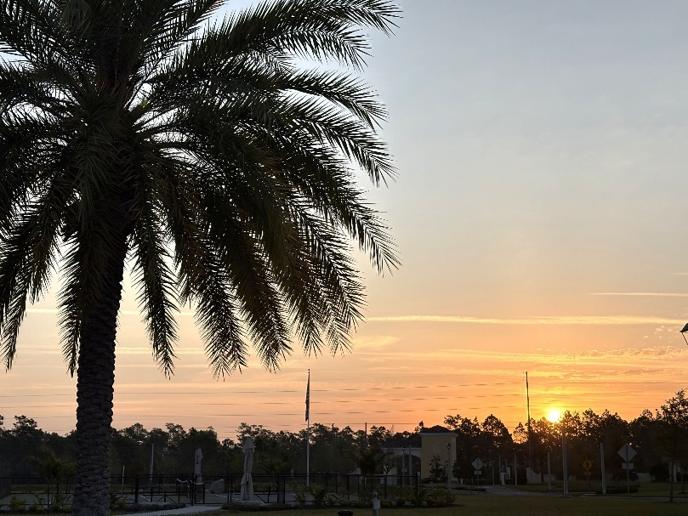
By Marsha Call

Up early like Photographer Dona Hams here is what we look like before sunrise.

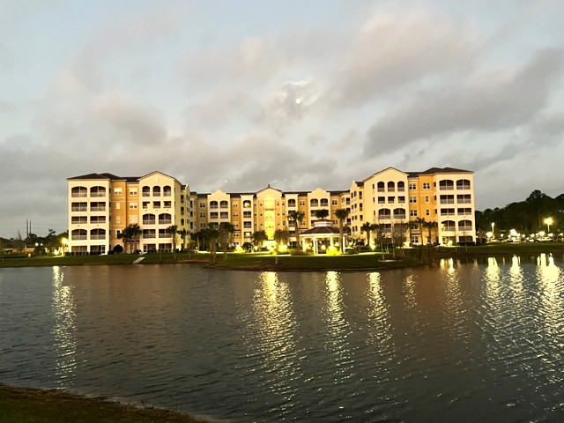

Feature Event


Photo from the Nature Conservatory

Earth Day
By Frank Russo

Did you know that Earth Day is celebrating 55 years of worldwide acknowledgement. Millions of people from every country participate each year. Now this sounds like quite an accomplishment. But think again. Our planet is almost 4 billion years old. It has taken us a long, long time to appreciate “Mother Earth” and the danger that she faces in the next hundred years.

The 2024 theme of Earth Day for the entire year was about the number of plastics particles found everywhere in our environment and in our bodies. The Legacy Pointe Independent Times did a feature article each month ranging from the piles of trash on our grounds and in our oceans to the more recent discoveries of the ‘plastic leftovers’ which shed micro and nanoplastics everywhere and collect in our bodies. For the first time science is taking this seriously and is beginning to do some in-depth research into what effects these nanoplastics particles are doing to everything and everybody.

Earth Day 2025 has a new theme for the next 12 months. The theme for 2025 is “supporting the tripling of renewable energy by 2030 with the theme Our Power, Our Planet, which is championing solar, wind, hydroelectric, geothermal, and tidal generated energy”.

Our worldwide power demands are not decreasing. People are using more and more energy which currently is being generated by massive amounts of fossil fuels. And the by-products of fossil fuels have a dramatic impact on our planet. They intensify greenhouse gases and add significantly to global warming.

And again, like the story of ‘plastics’ we are just starting to document the impact on human health. So, for the next 12 months The Legacy Pointe Independent Times will bring you the latest in what science is telling us about ‘renewable’ energy

Feature Presentation UCF President Visits Legacy Pointe

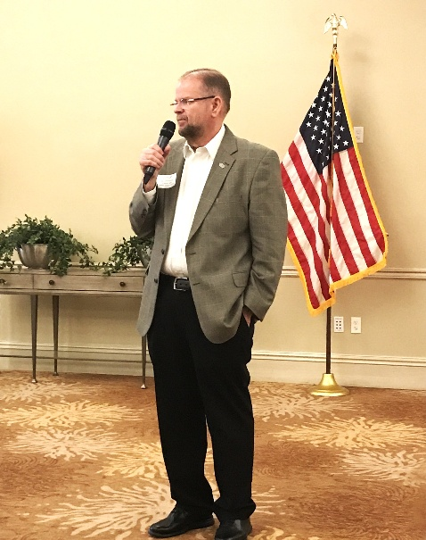

Dr. Cartwright photo by Larry Mitchell

On Thursday April 3rd Legacy Pointe welcomed a distinguished guest, Dr. Alexander Cartwright, the President of the University of Central Florida.
Dr. Cartwright was introduced by Bert Francis who is the President of our CCRC Board of Directors. Mr. Francis elaborated on the Presidents many achievements during his time at UCF
Dr. Cartwright holds a doctorate in electrical and computer engineering. He is the sixth President of UCF.

The occasion for his visit was to congratulate Legacy Pointe at UCF for its progress in achieving full occupancy and other notable milestones in such a short period of time. He also praised the recent purchase of the additional acreage which was owned by the UCF foundation. The purchase was made possible by a generous donation from one of the residents of Legacy.

He also talked about the growth at UCF, which exceeds 74,000 students and the direction in which the University was moving in the next few years.
The visit concluded with a visit to all the buildings and a light supper served by our kitchen and dining staff.

Spring a sign of Life
By Frank Russo

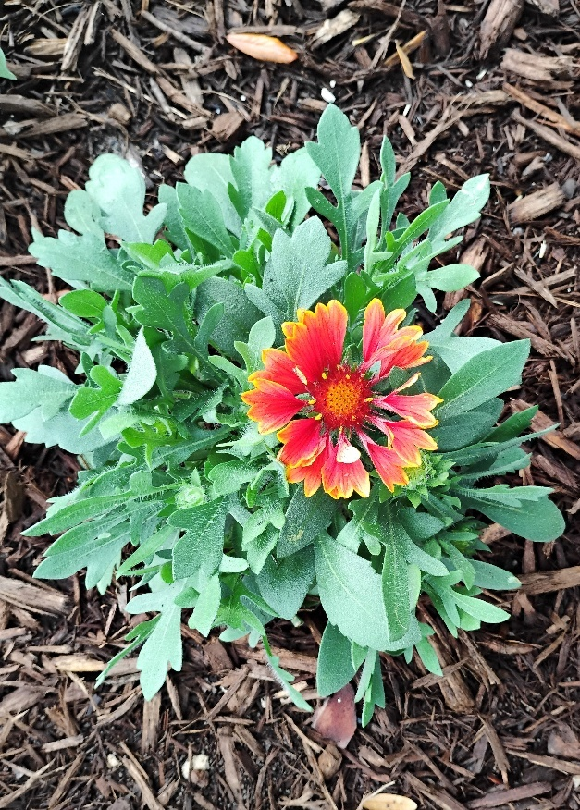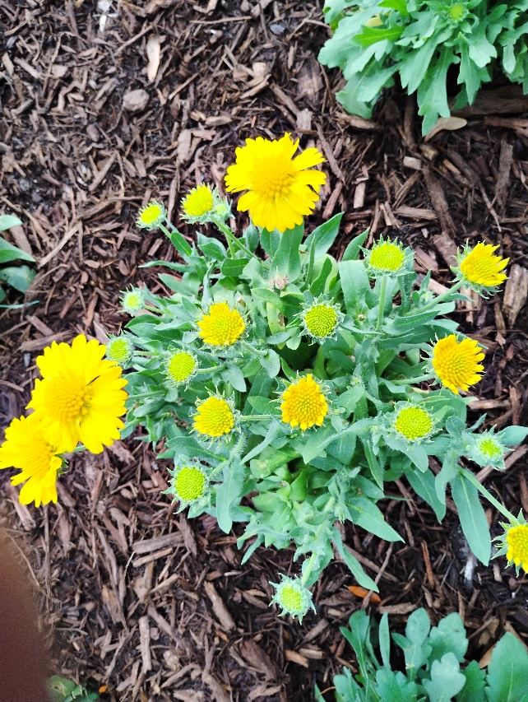

Story and Pictures scattered throughout this newsletter by Frank Russo

Go out and take a walk. Look out your window. Everything in nature is starting to ‘green up’. It happens every year. We call it the start of Spring. And it will happen regardless of what kind of winter we have had or how I am feeling. Sooner of later in April we will see Green and soon hundreds of other colors.

So, after you look ‘out’ then take some time and look ‘in’, meaning inside myself. Because this season can also have an internal impact. Our ‘psyche’ has been cooped up and it wants to green up. Some of us haven’t given our internal life a chance to sprout. For some reason we have allowed our spiritual soil to have hardened like a block of cement. And nothing will grow in that environment.

It is a good time to let our buds sprout. It will take some work, but it is worth it at any age. It will feel great to have an internal ‘green up’.

To help get this process started look around this edition of The Legacy Pointe Independent Times and you will find over two dozen pictures of life outside starting to spring up. One thing that ‘mother nature’ knows is that the growing season is short and Fall and Winter are coming. Sometimes in our ‘old age’ we don’t allow ourselves to loosen up our soil so we can grow.

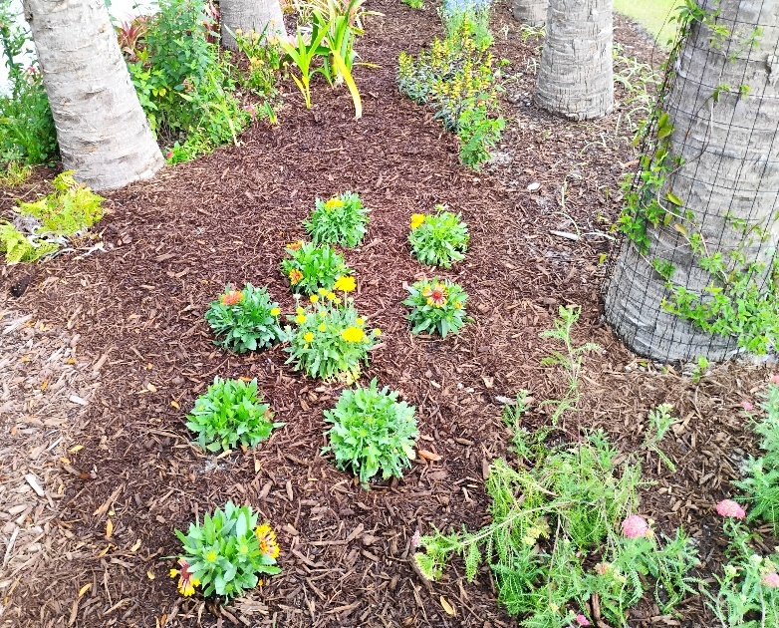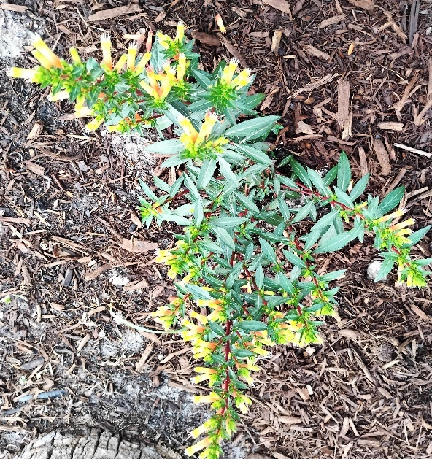

Follow up to our New Years Resolution Article

“National Quitters Day” was on January 18th? On this day approximately 80% of people who made New Year’s resolutions have tapped out by this date. So if you made it past January 18th congratualations you have done more than most people. And if you made it through March you are heroic.

So now it is April. And are you still working on your one resolution. Or you have chosen to do one resolution a month. If so you are on month number four. And resolution number four. If you are on four then make it a Spring resolution.

You’ve come this far so you know that you can do it. Keep it up

Legacy Pointe is a Wildlife Preserve

Long before we had Committees and sub-committees Tony and Kathryn Mennella along with the Garden Club spent a considerable amount of time following the national criteria for setting up Legacy Pointe at UCF as a Wildlife Preserve. The Pollinator Garden at the Gazebo and the Raised Bed plots have become a colorful addition to the L.P. surroundings.

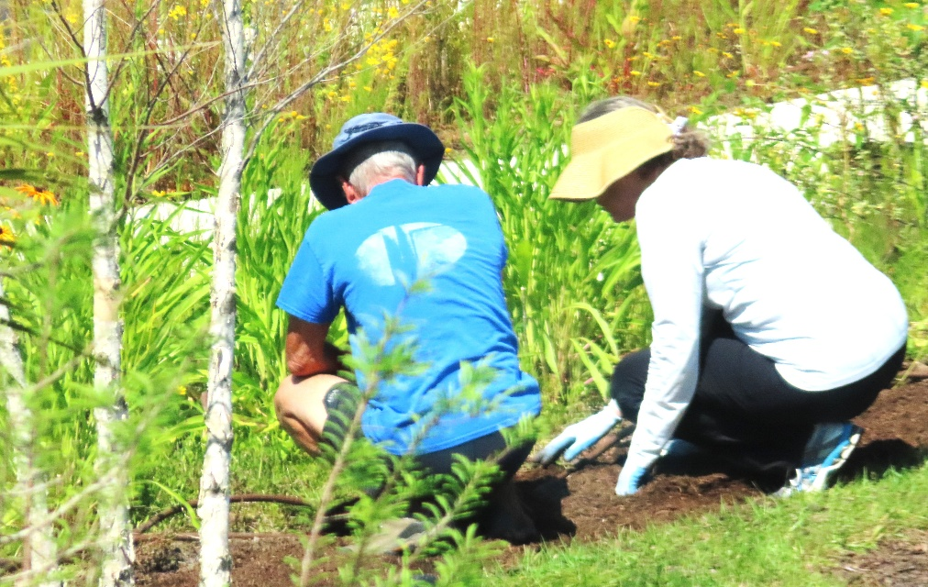

Tony and Kathryn are hard at work

And as far as wildlife goes here is a sample of creatures great and small who are regular visitors.

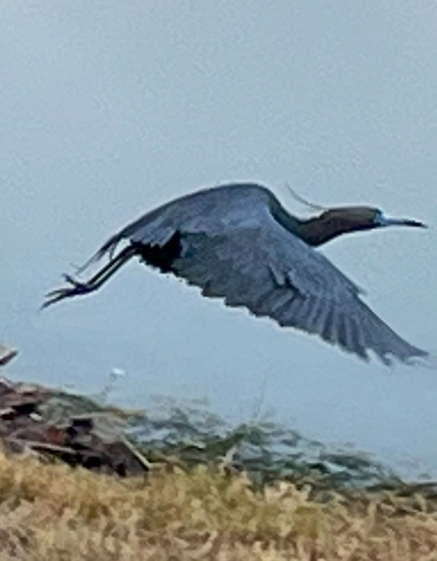

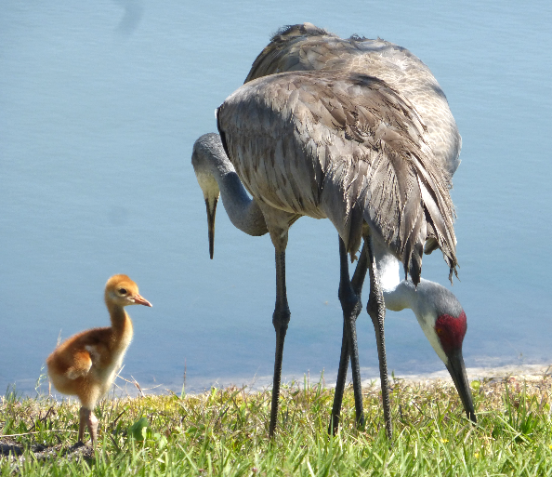

Photos by John Boldt

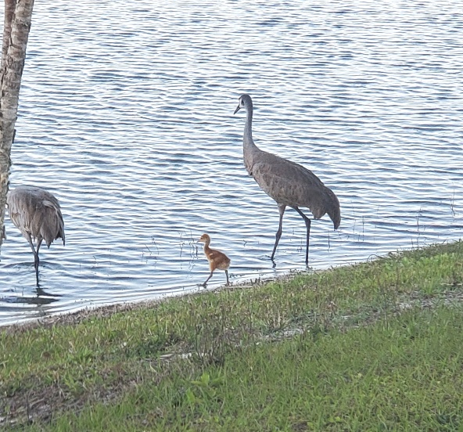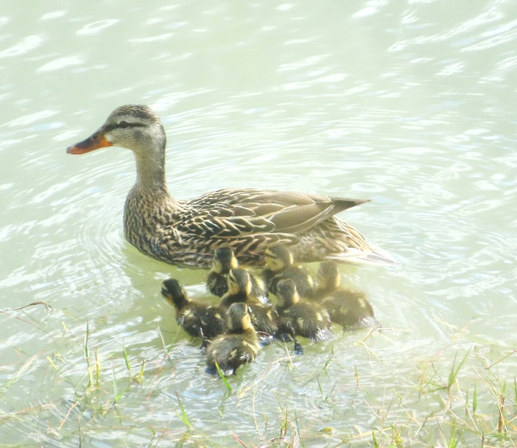

Photos by Lynn Worthington and Vicki Tindall

EARTH DAY IS REALLY 365 DAYS – Our Monthly Reminder
Get Ready we will celebrate a New Earth Day here at L.P on Saturday April 19th from 9 – 11 at the Front Entrance

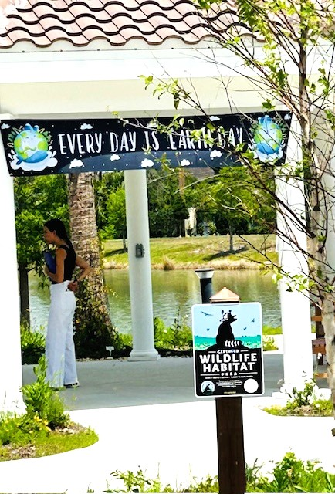
Photo by Maureen Reed

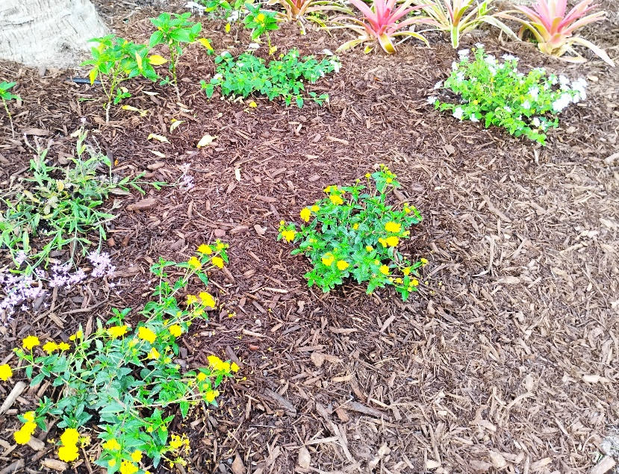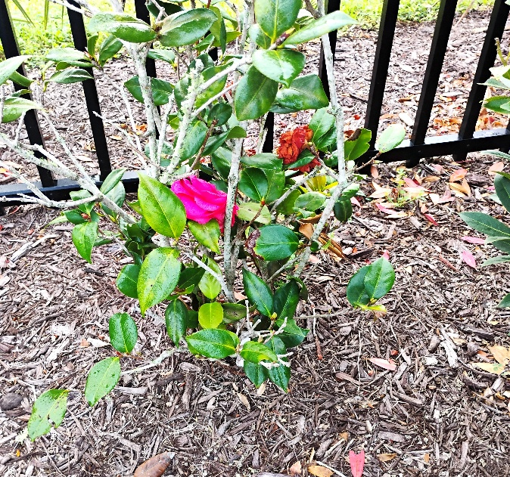

The Theme for Earth Day 2024 was “Planet vs. Plastics”
By Frank Russo
Starting with Earth Day 2024 the LP Independent Times has been focusing on the theme for this year “Planet vs. Plastics”. We have all seen pictures of piles of plastic. We are being buried in plastic. BUT it is not what we can see that is alarming. It is what we cannot see that is a matter of great concern.

Earth day is coming around for its yearly visit near the end of April. That means the LP Independ Times will have just one more feature article on plastics in our environment and shockingly in our bodies.

In this edition we will focus on what science finally finds out about micro and nano plastic particles lodged in our bodies. Unfortunately, since the chemical mega companies were not forthcoming about the dangers of the forever chemical components in plastics, we had no idea of the seriousness. The companies knew about ‘forever’ chemical ‘by-products’. Now finally science is doing its job and under investigation are the dangers of these chemicals.
There are dozens of studies ongoing worldwide on nanoplastics particles accumulating in our bodies. A very long semi-technical document is published by the National Institute for Health. If you have the patience you will learn a lot.
Impact of Microplastics and Nanoplastics on Human Health - PMC

New Mexico joins Maine and Minnesota in law to ban toxic 'forever chemicals' in products. The link is below
https://thehill.com/policy/energy-environment/5218010-new-mexico-ban-pfas-products-bills/

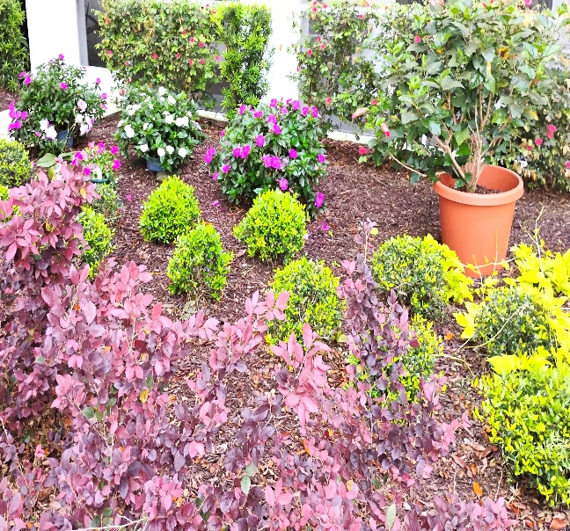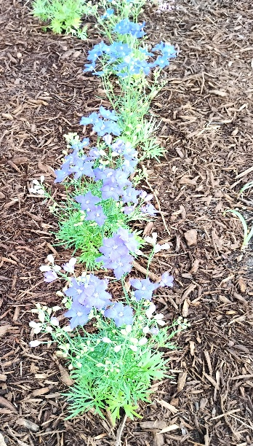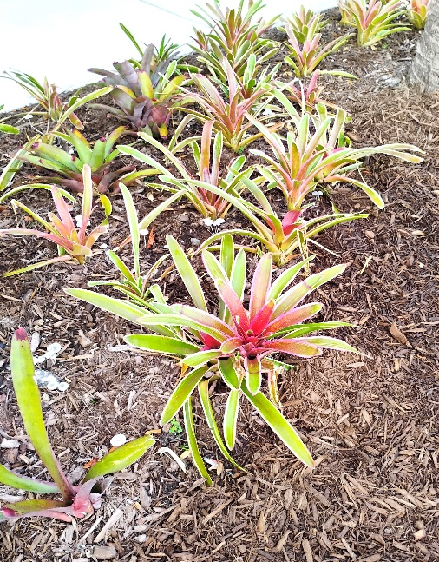

Legacy Pointe University

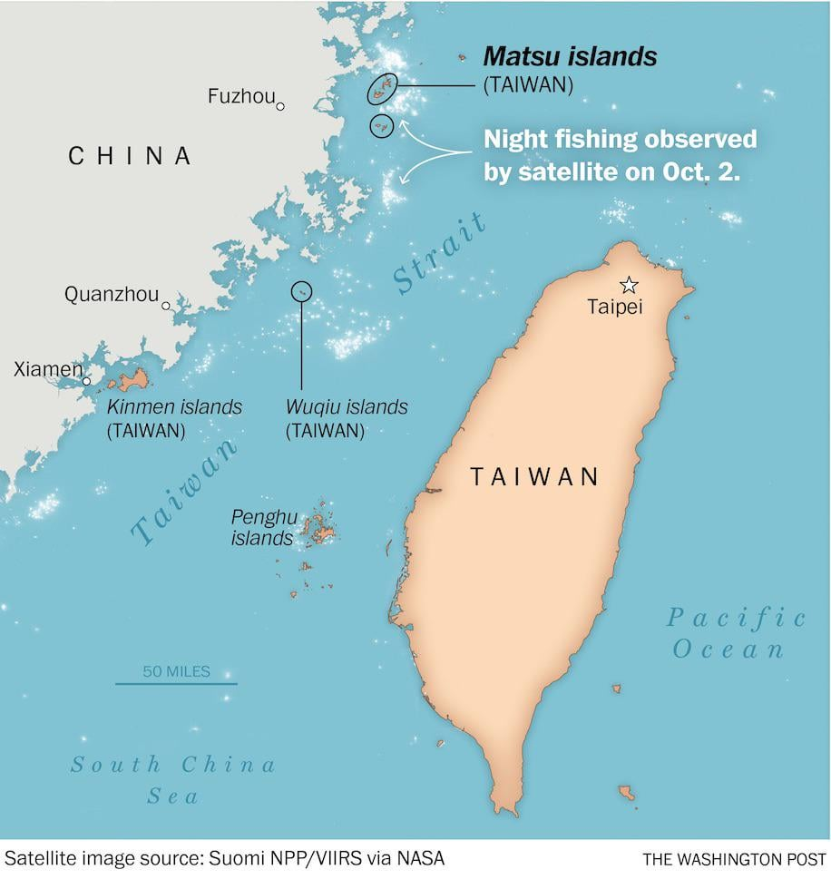

Mark your calendars for Thursday April 10th at 7:30 PM in the Auditorium. One of our residents Mitch Mitchell will discuss a topic entitled: Taiwan’s Offshore Islands: A Faded Line of Defense
Any resident that has heard Mitch before knows that this will be a very thorough presentation. Taiwan is a huge part of our foreign and military strategy to contain China..
There are approximately 168 Islands around Taiwan. Some are claimed by Taiwan and also administer by it. Some are claimed by Taiwan but not administered by it. All very confusing.
Perhaps Mitch will also talk about the Philippine’s new defense awareness and what it means for containing China strategically.



Opinion on Federal Department of Education
By Margaret Dunmire at pdunmire1@icloud.com

Peg Dunmire has written an opinion on the recent Department of Education policies. She knows that her opinion may result in opposing opinions. She wants to start a discussion’ Her words are
“This is as good a time as ever to have the public involved in determining how much we invest in education. Let the discussion begin”.

Her opinions may have several political implications in today’s environment. As a result, an editorial decision has been made. The first paragraph of her opinion article is printed below. Her full article will be sent to the Administrators of the L.P. Forum where similar discussions take place and other comments are included.
Unfortunately, the rhetoric about the Department of Education is very misleading. As a former School Board Director, I share the goal of local control of our schools. And that has been the historical policy of our country. The Department of Education was established in 1867 to gather data and statistics on the nation’s schools. That continues to be one of the main objectives of federal involvement. In the 1950’s the nation feared Russia’s launch of Sputnik as a wake up call to the US for improving our education. In addition, the Supreme Court ruled against “Equal but Separate Schools” and began the civil rights implementation in our schools. And finally, President Johnson began the “War on Poverty.” These three monumental changes in our country’s culture resulted in wide expansion of the federal involvement in education.
The expansion consisted of civil rights implementation e.g. Title I, II, III, etc. Funding for disadvantaged students and schools followed the expansion of Medicaid and the War on Poverty. Secondary education loans and grants was an expansion of education into colleges and community colleges support.
By dismantling The Department of Education, the federal government will continue to be very involved in these 4 areas: data collection, civil rights compliance, redistribution of taxes for the poor and support for secondary education (colleges).
See Peg’s full article in the L.P. Forum (lpresidentsonline.org) .
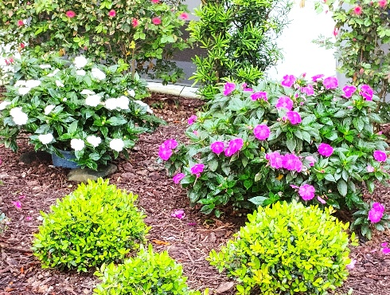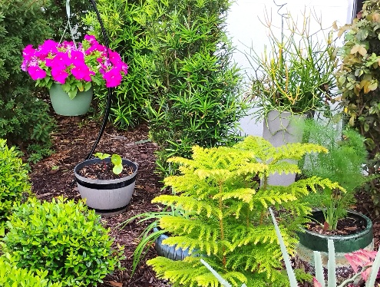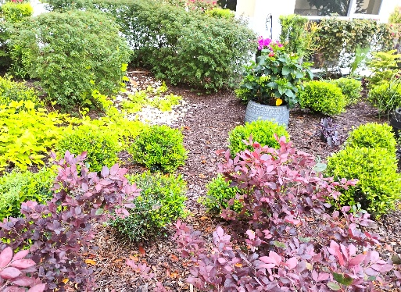

St. Patrick’s Day

Photo by Vicki Tindall
Once you see the pictures you will know it is St. Patrick’s Day at Legacy Pointe.

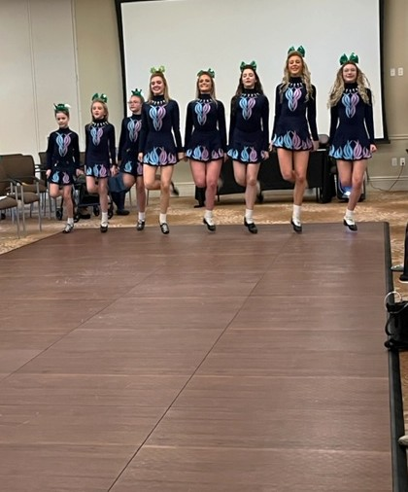
Photo by Dona Hams

Nursing Students Come to Legacy Pointe
April 1st brought to Legacy Pointe a new class of Nursing students from UCF. As part of their curriculum they will be spending some time at Assisted Living, Memory Care, and Skilled Nursing.
Pictured below are some of the students

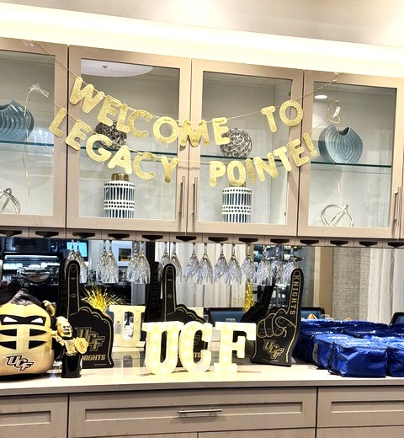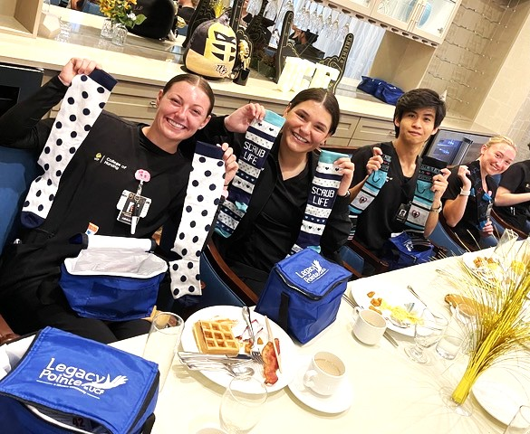
Photos by Amber Blevins

A Visit to the Honors Garden at UCF
A group of Legacy Pointe Residents Visited the UCF Honors Garden. The Honors Garden has been under careful care by one of our Legacy Pointe residents, Allyn Stearman. Allyn was a professor at the college before moving to Legacy Pointe.
As honors program participants, students automatically are members of the Honors Institute, which is devoted to the recognition and enhancement of the academic achievement of CF scholars.
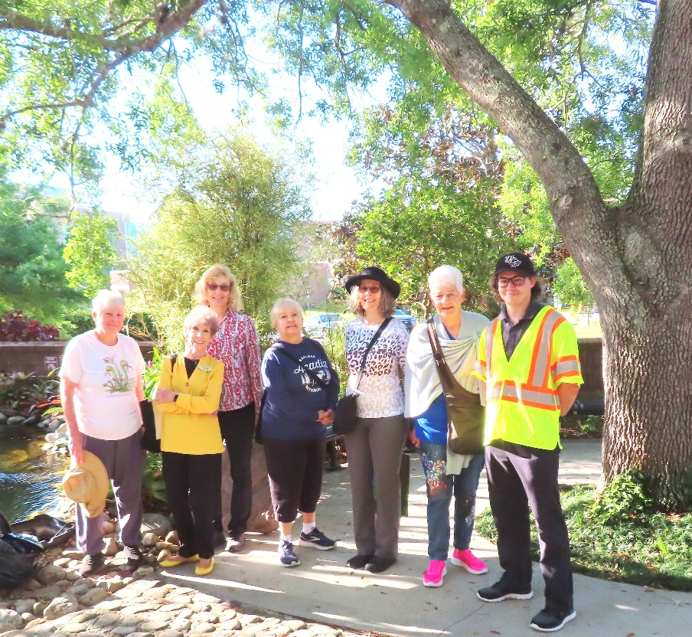
Photo by Vicki Tindall

A Visit to Wild Florida
On March 29th a group of L.P. residents took an adventure trip to Wild Florida.

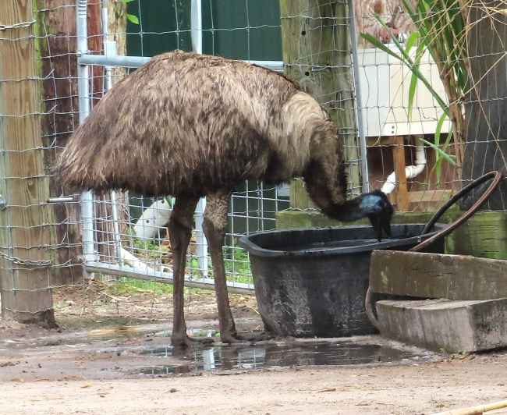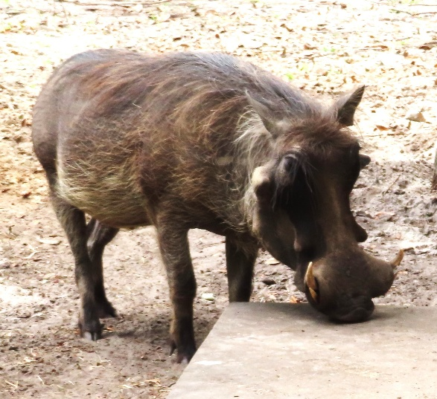
EMU WARTHOG
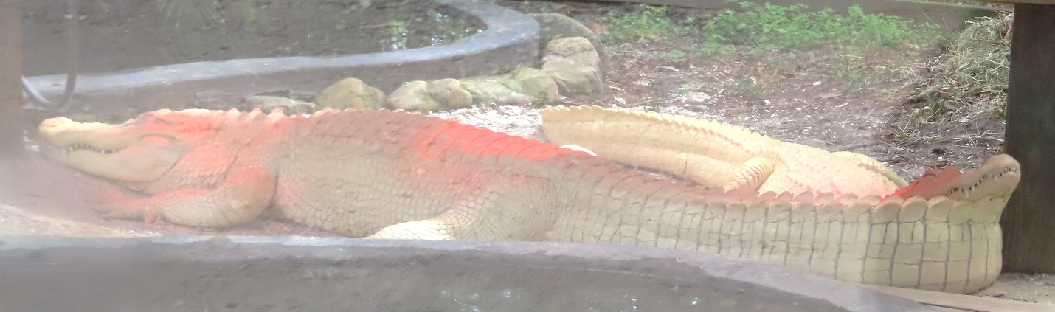
Albino Crocks

Time for a Rest

Monthly Beer Time
The beer lovers assembled for their monthly get together on Wednesday March 25th at 7 PM in the Bistro



AN ACCIDENT – Has it ever happened to you?

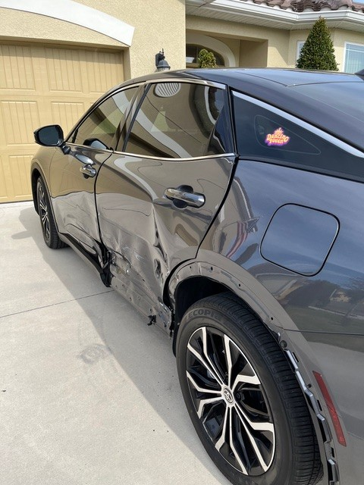

Today is a beautiful day and I am down in the dumps. My car is sitting in my driveway. Undrivable. I was hit on the driver’s side of the car Friday (March 30th) evening. I am fine. But I am down in the dumps.

When I was hit, I swerved to maintain control of the car as it twisted and slid across the road. The car came to a rest in the middle of the road. Cars continued to pass me on the opposite side of the road. Zoom. Zoom. I thought I’d better get off this road before I got hit again. I drove to the right as far as I could go but there was no room to get off of the road. I put my emergency lights on. I was totally alone. Cars all around me swishing and swerving to miss me. The outside world was dark. Inside my car, I was just sitting in the car wondering what to do. Call 911. I did. The operator asked which services I needed. I didn’t know. I had just been hit. Did I need medical assistance? I had been tossed around the driver’s seat but the seat belt kept me somewhat in one place. I remember feeling tossed to the right and to the left but I didn’t know if I were hurt. Do I need a police officer? Well sure! Send someone please. At this point, I didn’t even know if the person who hit me was still around. So I just sat in the dark waiting.

A knock at the passenger’s window. I was alone on the side of the road. Darkness. Should I open the window? Gingerly, I rolled down the window. The gentleman who hit me came to assure me that he was fully insured. He apologized. He said he didn’t even see me. At the very last second, he saw me and stomped on his brakes. He thinks that helped to turn his car so he hit me somewhat sideways instead of full on. He explained he was taking medicine to his son who couldn’t be near the newborn baby. He was a mess.

I assured him, we would be fine. This was an accident. That is why we have insurance. I imagined his stress: a new father; a sick son; and he just hit a car. Who was more stressed? Him or me?

The police officer came. We exchanged information. I called Nina. I asked her to come. I didn’t know what I was going to do. The officer suggested I drive the car to the end of the block and get off the road and park the car in a parking lot. Slowly I drove the car and did get off the road.

Eventually, I drove the car home slowly. Nina followed me. I had to crawl out of the passenger window to get out of the car. I reported the claim to my insurance company. I don’t really want to do anything more.

Two days later, I am home, sitting in a chair feeling blue. My dilapidated car is on display in the driveway. The heavens just opened up. Stop feeling sorry for myself! Head down and get on with life. Time to bake cookies.

Picture and article by Peg Dunmire

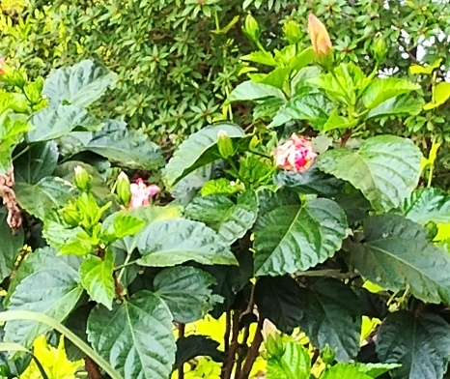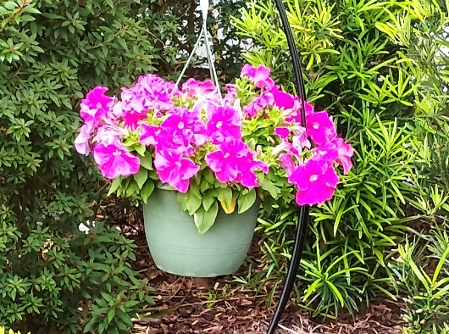


BOCCE BALL 2025 at LEGACY POINTE AT UCF

Bocce has some set times for Games each week they are:
Sunday 3 -4
Monday 11 – 12
Wednesday 11 -12
Saturday 10 -11

You can practice at any other times. The equipment is in the storage container next to the back door outside the Bistro and Dining room.

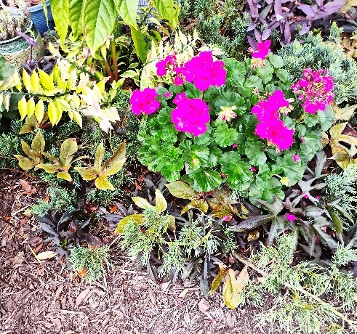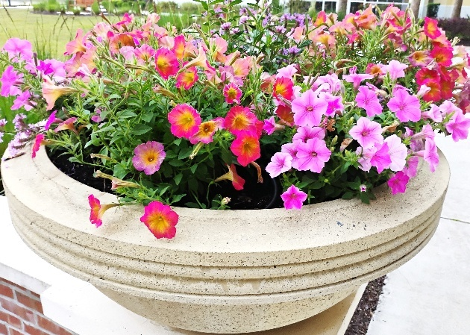

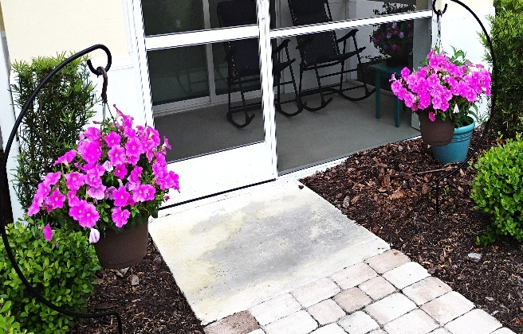

Bible Study
Each Monday, at 9 AM
in the Assisted Living Theater, second floor

These one-hour non-denominational sessions will be led by Mimi Rodriguez-Thompson, MDiv from Asbury Theological Seminary in Orlando.
Questions, comments: Tom Nixon btnix64@gmail.com

LET’S GO TO A MOVIE!
Here are the Legacy Point Movies for December 2024 and January 2025
UniGuest Activities provides a plot summary of each film. Movies are shown in the Auditorium at 6 PM unless otherwise noted.

Date |  | Time |  | Movie |  | Rating | Year |  | Run Time |  |  | Source/Host
Sunday, 4/13/25 |  | 6 |  | The Gods Must Be Crazy |  | PG | 1980 |  | 1h 49m |  |  | BW/VT
Tuesday, 4/15/25 |  | 4:00 |  | Movie Committee Meeting - 4PM (1 time only) |  |  | --- |  | --- |  |  | BW
Sunday, 4/20/25 |  | 6 |  | The Robe |  | PG | 1953 |  | 2h 15m |  |  | BW/BW
Sunday, 4/27/25 |  | 6 |  | The People We Hate at the Wedding |  | R | 2022 |  | 1h 40m |  |  | BM/BW
Sunday, 5/4/25 |  | 6 |  | Under the Tuscan Sun |  | PG13 | 2003 |  | 1h 52m |  |  | BW/BW
Sunday, 5/11/25 |  | 6 |  | The Net |  | PG13 | 1995 |  | 1h 54m |  |  | BW/LR
Sunday, 5/18/25 |  | 6 |  | Animal House, National Lampoon |  | R | 1978 |  | 1h 46m |  |  | BW/JL
Sunday, 5/25/25 |  | 6 |  | The Big Easy |  | R | 1987 |  | 1h 36m |  |  | BW/VT
Sunday, 6/1/25 |  | 6 |  | Last of the Mohicans |  | PG13 | 1992 |  | 1h 54m |  |  | BM/BW
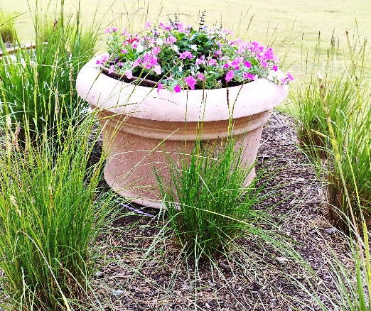

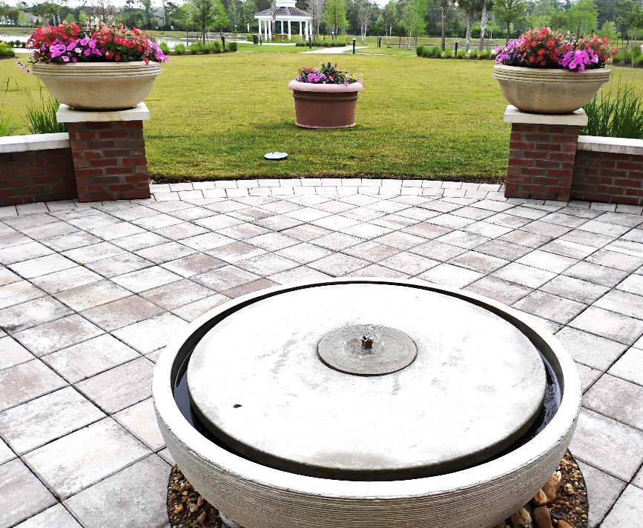

GARDENER’S CORNER
“We Come From The Earth
We Return To The Earth
And In Between We Garden”
By Alfred Austin

Gardening on your balcony
Many Legacy Pointe residents would like to grow something but do not want to garden outside. So, the Gardener’s Corner will try to offer suggestions for things you can grow on your balcony.
If you are new to gardening let’s start off easily. How about a tomato plant, a pepper plant, 2 green bean plants, and some lettuce plants.

The transfer days moving the seedlings from starter containers to large pots is done in APRIL. NOW DO IT.
Contact Frank Russo at 407-341-7622 to ask for help.

Here is what you will need to transfer to a large pot. (DO NOT SPEND MUCH MONEY)
You will need a large pot to transfer seedlings. (Buy large pails/buckets at Dollar Tree based on the number of seeds you are transplanting. These cost $1.25 each versus what you would spend at a nursery which could cost $10 each. Punch 3 holes in the bottom of each bucket for drainage and you have your pot for growing each of your plants.
You will need a bag or more of garden soil and some potting soil. to mix with the garden soil. (The size bag depends on what weight you can carry). (Ace Hardware has smaller bags which are easier to carry.)
You will also need some fertilizer. A small bag for vegetables is fine.
Be careful in transferring your plants so that you do not damage the fragile roots. When finished put a half teaspoon of fertilizer in the soil of each pot
Two weeks ago, I finished transferring my plants to buckets with holes in the bottom. They are all doing fine. My beans are starting to have flowers.
More instructions in May L.P. Independent Times for caring for your plants

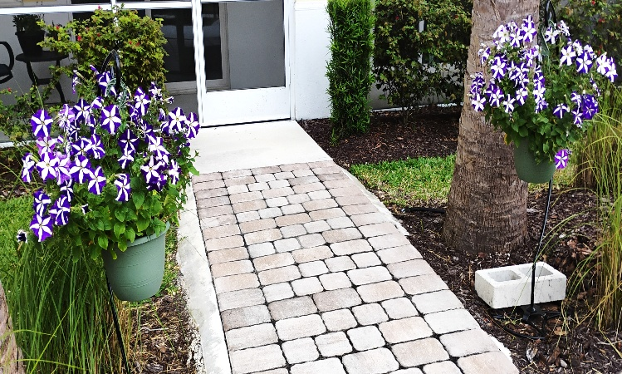

SOCIAL, PHYSICAL, & NUTRITIONAL ASPECTS OF “SENIOR LIVING”
Shared for your interest … we do not make any claims or recommendations.
We welcome articles and videos that you see on the web concerning health issues we all face in our environment and especially in our food. Processed foods are the real health dangers since they contain many different chemicals and dyes. Currently one of our residents has done a lot of investigating on the web and has contributed different articles and links to web documents. She is Mary Catherine Ricks. Her article this month is below. This is followed by two web links that you may find interesting if you have grandchildren who may consume too much processed food.
If you find interesting articles forward them to me at frankrusso2012@gmail.com

Seniors’ Nutrition Information, Your Guide to Eating Well
Some Ways Healthy Eating Affects Physical, Mental and Social Health
Today as part of our ‘healthy eating’ section we are going to look at the benefits of drinking tea. This article deals with black tea. Tea has many different colors and tastes. And as much research shows that teas are very beneficial to your overall health. The only thing that we have to be concerned about is the packaging of the tea bag. Some companies are using plastic in their tea bags. The tea itself is good. The plastic bags are very dangerous leeching out billions of nano-plastic particles into our teacups and as a result into our bodies. So drink tea but be careful of which companies use plastic.
The link to the article below will give you the latest information It was published on January 31, 2025

Diet and Nutrition
10 Health Benefits of Black Tea, Supported by Research
By Amy Brownstein, MS, RDN Published on January 31, 2025 Medically reviewed by Allison Herries, RDN
https://www.verywellhealth.com/benefits-of-black-tea-8746881

DO YOU NEED TO GET OUT AND DO SOMETHING?
Do you want to take a little trip for a change of scenery? Check out these 25 suggestions for short trips from Oviedo!
https://www.orlandoweekly.com/orlando/25-easy-weekend-road-trips-from-orlando-everyone-should-do-at-least-once/Slideshow/35988297/35989533

A Farmer’s Market Adventure
A couple of weeks ago a busload of residents headed to Orlando at Lake Eola for the Farmers Market. Here is one picture. It hardly seems like the group went to a farmer’s market. It looks like they went to a circus.

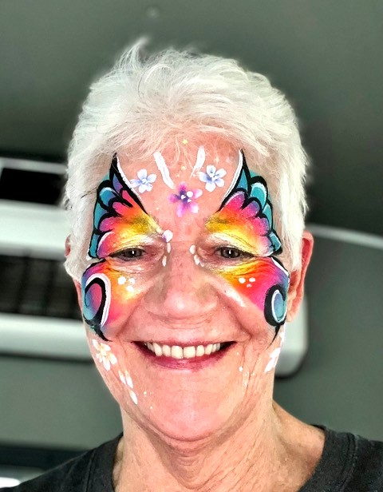

IF YOU DON’T WANT TO LEAVE LEGACY POINTE …
Check out Kristina Ferry's weekly Activity email postings to LP residents! See also the daily/weekly Activities section in the UniGuest app.
Here are some of the many available clubs and activities to participate in:

- Arts & Crafts: Artist’s Club; Blanketeers Workshop

- Dance: Dance Club; Line Dancing

- Exercise: Aqua Aerobics; Low Impact Cardio Dance; Sunrise Tai Chi; Chair Fit; Silver Sneakers; Yoga (Seated, Chair and Mat versions)

- Fun & Games: Bridge (Casual; Practice Group; Evening Group); Canasta; Chess; Game Night; Mahjong; Mexican Train Dominoes; Spade

- Gardening: Garden Club

- Literary: Book Club; Writer’s Group

- Music: Recorder (wind instrument) Class; Voices of Legacy Choir

- Veterans: Veterans Special Interest Group(s)

THE LEGACY POINT BOOK CLUB

The Legacy Pointe Book Club meets on the third Tuesday of the month at 3 PM in the Card Room

Our Book for April 15 is called The Women by Kristin Hannah


Women can be heroes. When twenty-year-old nursing student Frances “Frankie” McGrath hears these words, it is a revelation. Raised in the sun-drenched, idyllic world of Southern California and sheltered by her conservative parents, she has always prided herself on doing the right thing. But in 1965, the world is changing, and she suddenly dares to imagine a different future for herself. When her brother ships out to serve in Vietnam, she joins the Army Nurse Corps and follows his path.
As green and inexperienced as the men sent to Vietnam to fight, Frankie is over-whelmed by the chaos and destruction of war. Each day is a gamble of life and death, hope and betrayal; friendships run deep and can be shattered in an instant. In war, she meets―and becomes one of―the lucky, the brave, the broken, and the lost.

Our Book for May 20 is called The Life Impossible by Matt Haig

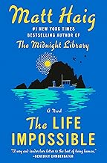
When retired math teacher Grace Winters is left a run-down house on a Mediterranean island by a long-lost friend, curiosity gets the better of her. She arrives in Ibiza with a one-way ticket, no guidebook and no plan.
Among the rugged hills and golden beaches of the island, Grace searches for answers about her friend’s life, and how it ended. What she uncovers is stranger than she could have dreamed. But to dive into this impossible truth, Grace must first come to terms with her past.

Recipe – Firefighter’s Cornbread

I came across this recipe recently for cornbread. If you are a real Southerner, you will be shocked and give it a thumbs down just based upon the list of ingredients. But remember who the recipe is from. They do not have the time to do anything fancy or time consuming.
Here is the link if you want to try it.

https://www.simplyrecipes.com/firefighters-secret-to-the-best-cornbread-8705774

FYI ~ THE LP NEWSLETTER LOGO

The blue and yellow leaves represent Legacy Pointe's colors.

The green leaves (growing higher) represent the continuing growth provided by our residents.

This beautiful design was created by LP resident Jonathan Wahl.

SURFING THE INTERNET

You could spend your whole day just sitting and surfing. If you do this your entire body will fall apart from lack of exercise. So, our newsletter is asking its readers who spend just a few minutes a day surfing to send along some links to articles that may be interesting or funny or extremely important. Send links to Frank Russo at frankrusso2012@gmail.com

This month’s surfing produced a number of articles about science identifying the first building blocks of life to appear on earth. In an article entitled:

Last Universal Common Ancestor (LUCA) Is Much Older Than We Thought
Would you believe 4.2 billion years ago?

Here is the link. Read the article and make your own decision
https://www.popularmechanics.com/science/environment/a64186168/single-ancestor-life-luca-discovery/

Feedback? Stories? Photos?
Send to Frank Russo at frankrusso2012@gmail.com

SPACE LAUNCHES AT KENNEDY SPACE CENTER FOR APRIL 2025

Space Shuttle Launch to International Space Station

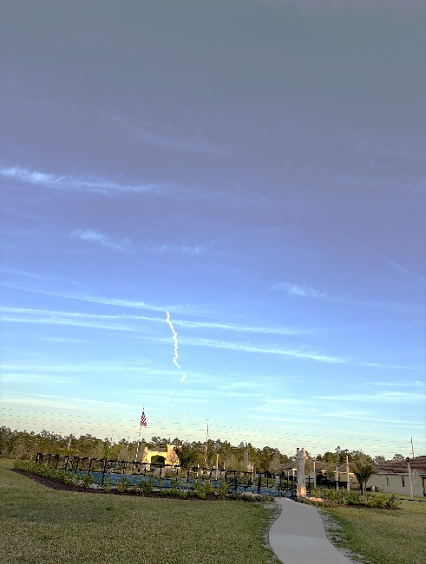
Photo by Marsha Call Photo by Vicki Tindall

There are many launches scheduled this month and next click on the link below to get the days and times


Photo by Joyce Swing

For list of all Launches check this website suggested by John Boldt.
https://nextspaceflight.com/launches/

THE LEGACY POINTE RESIDENTS FORUM

Remember to SIGN UP for the LP Residents Forum!
https://lpresidentsonline.org/smf

You can easily set up your login and password. The Forum is a place for you and your neighbors to come together . . . To create a knowledge base . . . To go beyond a community to becoming a family. We hope to see you online soon. If you need help, email Forum Administrators Jonathan Wahl 47ipsd@gmail.com or Ina Hunt utgrad@attglobal.net

And in case you missed any issues, click the following link to access the complete Newsletter Archive: LP Residents Forum - Residents Newsletters (lpresidentsonline.org)

Please check out In Memoriam, the latest Category on your Legacy Pointe Forum. It is a place where we can express our love and memories of cherished members of our Legacy Pointe Family who are no longer with us. A place to celebrate their lives and ensure they will not be forgotten. And a place to draw comfort from our shared memories. Please feel free to share pictures, stories, memories, tributes, and obituaries. To Create a memorial, click New Topic and type the person's name. To add your sentiments to an existing memorial, click Reply.
If you have any questions, please contact Forum Administrators Jonathan Wahl or Ina Hunt (email addresses above).

OUR DAY ENDS

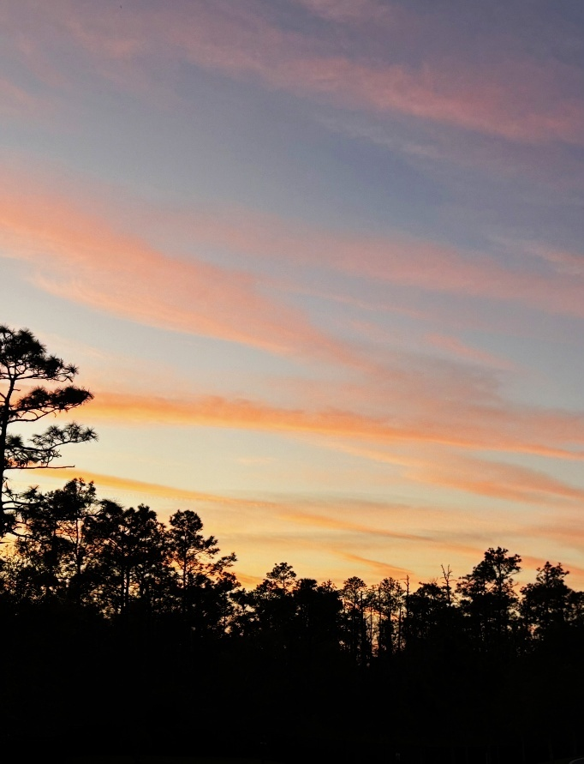

Sunset by Marsha Call

